FREQUENTLY ASKED QUESTIONS
Lottery No. | Lottery 205 – Southport
Lottery Start Date | 12.01am, Wednesday 31st March 2021
Lottery Close Date | 4pm, Wednesday 23rd June 2021
Lottery Draw Date | 11am Wednesday 30th June 2021
Prize Home Address | 35 Ridgeway Ave, Southport, QLD 4215
Home Features | House Details:  - Living Area 221m2 + 46m2 outdoor areas  - Land 409m2  - 4 Bedrooms  - 3 Bathrooms  - 2 Car internal access garage  - 2 exterior patios/veranda’s, ducted air con, WIR, Inground swimming pool  PRIZE PACKAGE  Find your perfect family oasis in this luxury $1.3 Million Southport home on the Gold Coast. This spectacular home features open plan living spaces, four spacious bedrooms, three bathrooms an inviting pool and stunning views across to Surfers Paradise skyline.  With a gorgeous free-flowing interior, this home has your every need considered with a luxury design and interior package worth $161,5771!  Enjoy the investment potential of this highly sought-after Gold Coast location and earn up to $50,700* of rental income each year! Or choose to live a carefree lifestyle close by schools, green zones, and pristine beaches.  Here is what our lucky winner will get:  - $1.15M Luxury Home  - Incredible interior and appliance package worth $161,577  - Gold bullion worth $10,000  Total Prize package $1,321,577!
First Prize Value | 1st Prize value: $1.3 Million ($1,321,577)
Gold included in First Prize | Includes $10,000 Gold Bullion
Additional Prizes | N/A
Design & Furniture Package Value | $161,577 design and furniture package
Body Corporate Fees | No Body Corporate fees apply
Estimated Rental Income | $975 pw, $50,700 p.a.
Council Fees | Council Rates $1673.73 p.a. for 12 months*.  * This estimate does not include the cost of water usage and waste collection * This estimate does not include the cost of water usage and waste collection.
Location | From the destinationgoldcoast.com website.  If you squint into the sunshine and cast your mind back a little over a century ago, you can almost picture the Southport of old; one of the Gold Coast's earliest and most fashionable seaside destinations.  This area has a rich and romantic history, which in the 1890s, attracted the well-heeled for its sideshow theatres and pier. Now the bustling CBD for the Gold Coast, Southport's eclectic appeal remains. Just north of Surfers Paradise, this business, shopping, dining, and residential hub overlooks the dazzling Broadwater and Southport Spit, mixing a touch of city spice with natural beauty.  Shop at Australia Fair Shopping Centre or stroll the streets to discover some fantastic new eateries and boutique shops. Cross over Marine Parade and you can escape to the manicured Broadwater Parklands where you can wander along seaside tracks, splash with the kids in the water park or visit the Aquatic Centre with three pools, gym, and café.  At night, the precinct transforms into a food mecca with authentic multicultural restaurants dotted throughout the glowing streets. From Korean and Vietnamese to Italian and Turkish, it truly is a foodie explorer's heaven.  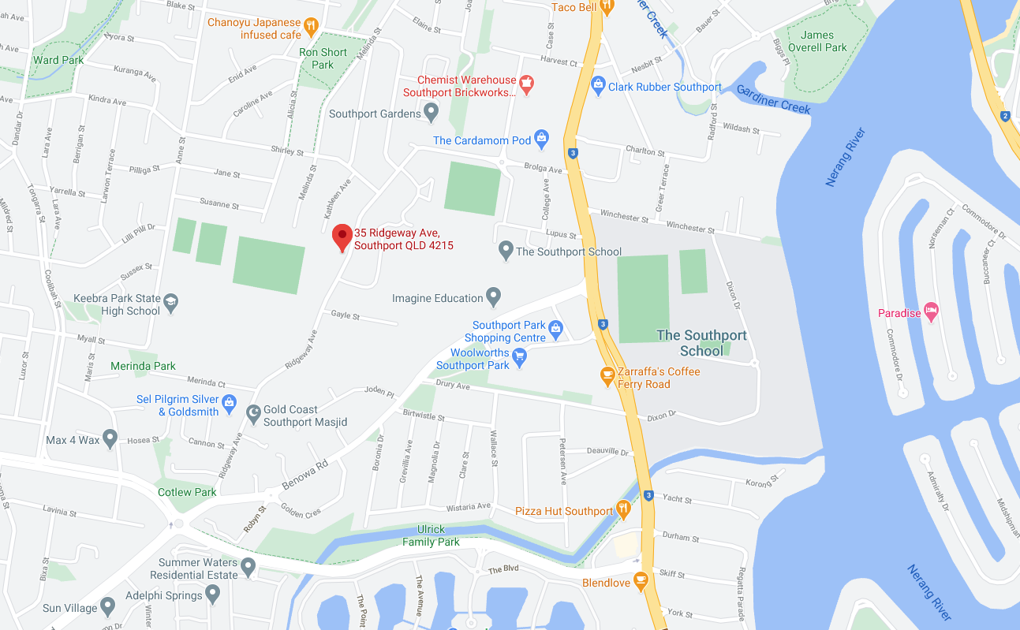  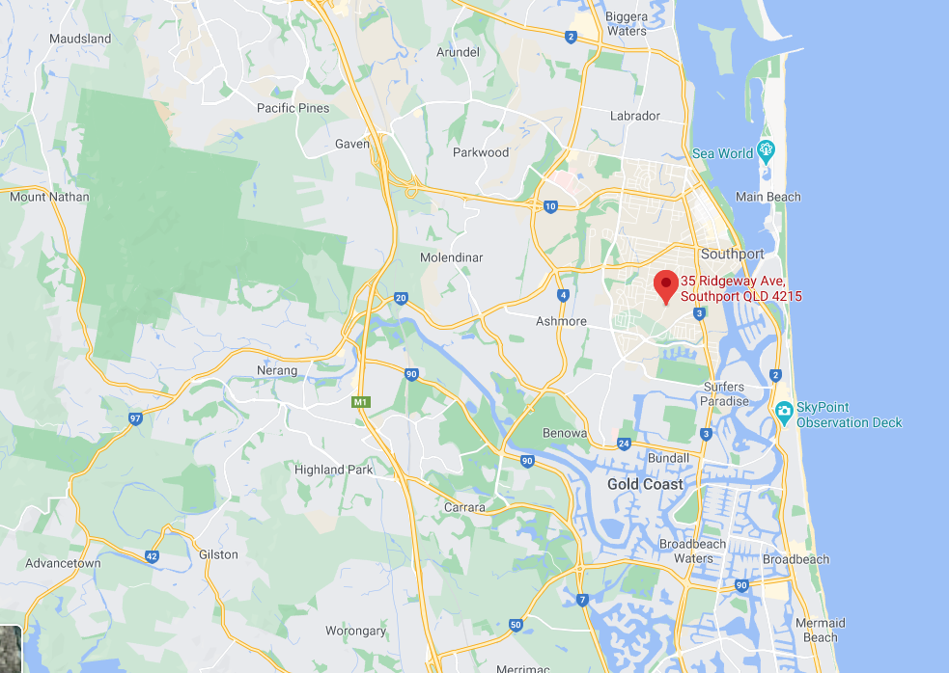  Travel Times:  - Australia Fair – 8 Minutes’ drive (3.3km)  - Ferry Rd Markets – 2 min drive (750m)  - Broadwater Parklands – 10 min drive (3.7km)  - Surfers Paradise – 7 min drive (3.4km)  - GC Aqua Park, Inflatable Water Park – 8 min drive (3.4km)  - The Rockpools – 9 min drive (3.6km)  - Gold Coast Aquatic Centre – 9min drive (3.4km)  - The Brickworks Centre – 2 min drive (900m)  - Anzac Park – 8 mins drive (3.3km)  - Southport Park Shopping Centre – 4 Minutes’ drive (1.9km)  - The Southport School – 5 mins drive (1.8km)  - Brisbane – 56min drive (74km)  - Stradbroke Island Ferries – 1hr 4 mins (72km)  - Coolangatta – 37 min drive (42km)  - Kingscliff – 45 mins drive (54km)  - Byron Bay – 1 hr 19min (105km)  - Coffs Harbour – 3hr 22min (324km)  - Sydney – 8hr 49Min (855km)
Property Size | - Living Area 221m2 + 46m2 outdoor areas  - Land 409m2
Open House Dates | The house will not be open for inspection
House Direction | 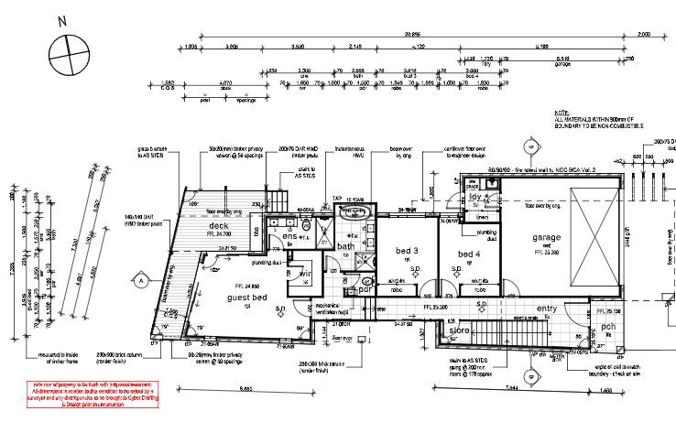
How many tickets are in the draw? | There are a maximum of 6,000,000 tickets available.
Next prize home lottery? | The next prize home lottery (number 206) will be an amazing 4-bedroom sub-penthouse apartment in Birtinya on Queensland’s Sunshine Coast.
Draw Results | Results published 11am Wednesday 30th June 2021.  Winners advised by registered post. Results published 30/06/2021 on Surf Life Saving Lottery website www.surflottery.com.au and on 5/07/2021 in The Australian newspaper.

