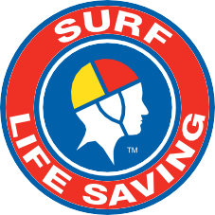
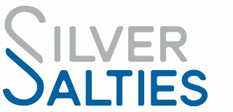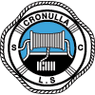

JOIN SILVER SALTIES! FUN, SAFE, SOCIAL AND HEALTHY!

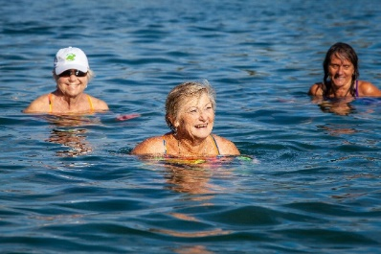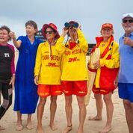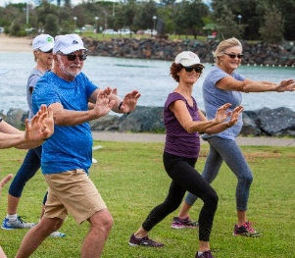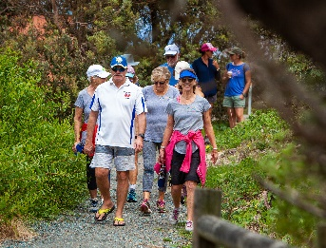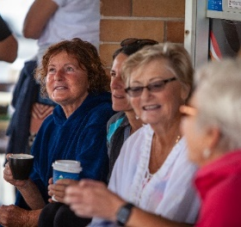

Silver Salties is a physical activity and social connections initiative for older Australians designed by Surf Life Saving Australia in conjunction with Surf Life Saving Clubs and funded by Sport Australia’s Move It Aus – Better Ageing Grants Program. Older Australians are a diverse group and could be any age
e.g. 65yr+ or younger!

Silver Salties includes accessible, friendly, safe, and beneficial activities at the park, clubhouse, beach, pool, and surf which cater for older Australians regardless of their age, weight, mobility, fitness, and experience. Morning tea afterwards is always
encouraged too!

Silver Salties is:
- Social and fun
- Safe, including
Insurance cover
- Beneficial for physical health and fitness
- A small time commitment
- For all older Australians in the community!

JOIN THE SILVER SALTIES PROGRAM AT
Cronulla SLSC
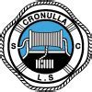

and be part of the surf lifesaving community!

PROGRAM: Silver Salties Catching Waves Program

DAY & TIME: Every Wednesday 9.00am
Starting 17 February 2021 for 7 weeks

COST: FREE

MEETING POINT: Cronulla SLSC (beachside – look for Silver Salties banner)

OTHER: Program is based on the fantastic WA Granny Grommets group. Coaching provided. Bring your own bodyboard and fins if possible. A limited number of loan boards will be available.

CONTACT: To register go to: https://www.revolutionise.com.au/cronullaslsc/events/88537/
Or contact Laura on 0402 486 093 or Silversaltiesambassador@sls.asn.au

